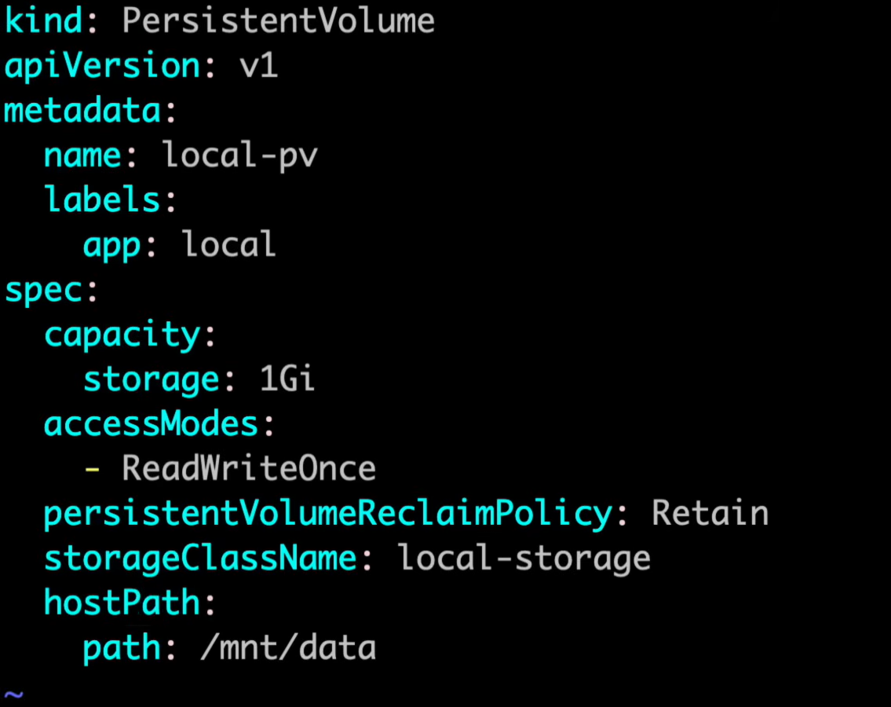
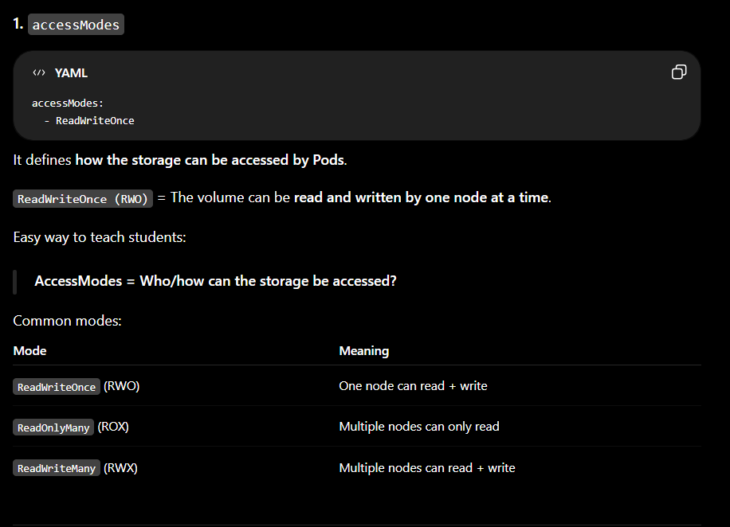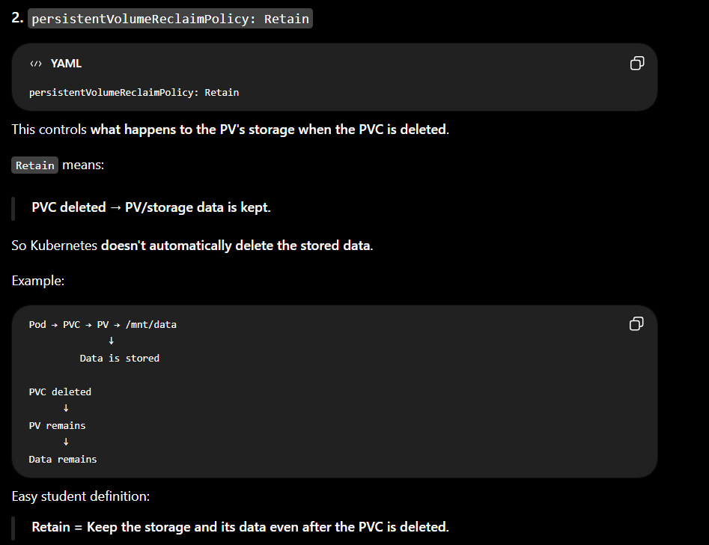
presistentVolumeClaim
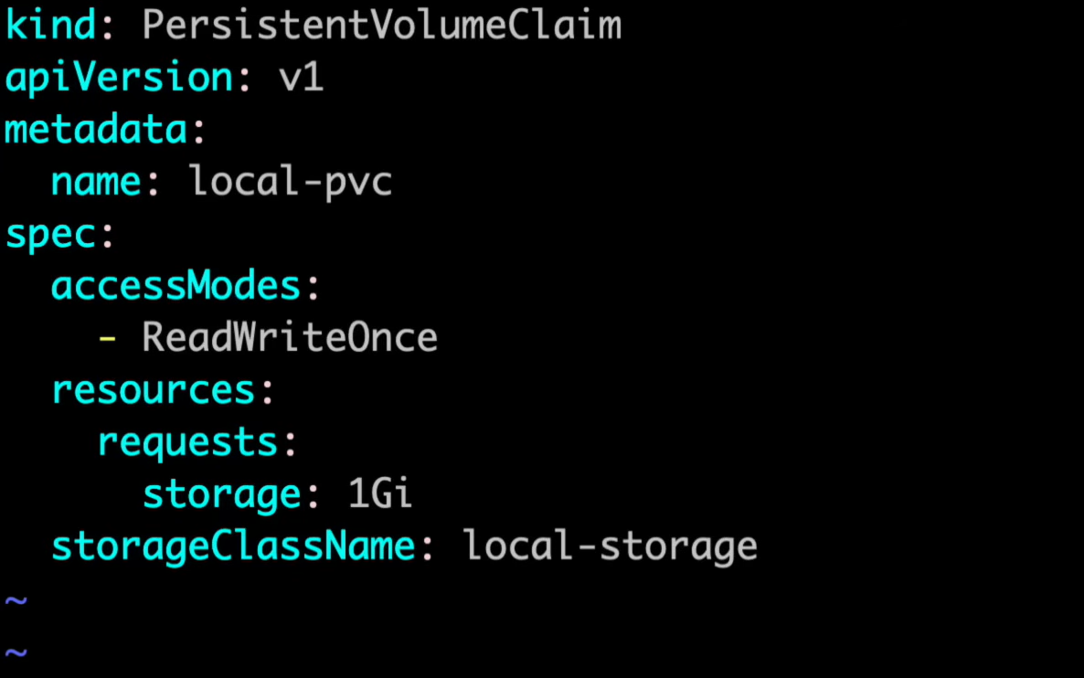

DYNAMIC VOLUME USING EBS

Flow
Pod
↓
PVC (I need 10Gi storage)
↓
StorageClass
↓
EBS CSI Driver
↓
AWS EBS Volume is automatically created
↓
Volume attached to Kubernetes Node
↓
Pod uses the volume
1. StorageClass
apiVersion: storage.k8s.io/v1
kind: StorageClass
metadata:
name: ebs-sc
provisioner: ebs.csi.aws.com
volumeBindingMode: WaitForFirstConsumer
ebs.csi.aws.com tells Kubernetes:
Use the AWS EBS CSI driver to create the volume.

2. PVC
apiVersion: v1
kind: PersistentVolumeClaim
metadata:
name: ebs-pvc
spec:
accessModes:
- ReadWriteOnce
storageClassName: ebs-sc
resources:
requests:
storage: 10Gi
Here the student says:
"I need 10 GB storage."
They don't create a PV manually.
Kubernetes dynamically creates the PV and AWS EBS volume.

3. Deployment
apiVersion: apps/v1
kind: Deployment
metadata:
name: nginx
spec:
replicas: 1
selector:
matchLabels:
app: nginx

template:
metadata:
labels:
app: nginx

spec:
containers:
- name: nginx
image: nginx
volumeMounts:
- name: ebs-storage
mountPath: /usr/share/nginx/html

volumes:
- name: ebs-storage
persistentVolumeClaim:
claimName: ebs-pvc
Commands
kubectl apply -f storageclass.yaml
kubectl apply -f pvc.yaml
kubectl apply -f deployment.yaml
Check:
kubectl get sc
kubectl get pvc
kubectl get pv
kubectl get pods
You can also check AWS:
AWS Console → EC2 → Elastic Block Store → Volumes
You should see the EBS volume created automatically.
The important difference
Static provisioning:
Admin → creates EBS → creates PV → PVC → Pod
Dynamic provisioning:
Admin → StorageClass

Developer → PVC → Kubernetes automatically creates EBS + PV → Pod
For your students, the easiest line to remember is:
StorageClass defines how storage should be created, PVC requests the storage, and Kubernetes automatically creates the EBS volume.
One important EBS point: EBS is block storage and normally uses ReadWriteOnce,

